
Academic Associates PeaceWorks

NO 10 Chief Umeh Street,
Off Saint Michael Street, by Ada George,
Port Harcourt, Rivers State, Nigeria.
Tel: +234 915 310 7741,
aapeaceworks@yahoo.com; www.aapw.org

Coping with Climate Change as a Cause of Conflict in Coastal Communities of West Africa (C7-WA)

Report - Advocacy Visits for 10 Communities and Training for Community Stakeholder Networks (CSN) on Climate Change and Conflict Management
February – July 2024
State: | Cross River, Akwa Ibom, Rivers, Bayelsa and Delta
Type of Activity: | Advocacy Visits for 10 communities and Training of Community Stakeholders Network (CSN) on Climate change Mitigation, Adaptation and Conflict Management
Venue of Activity: | Cross River (Creek Town and Esuk Mba Communities), Akwa Ibom (Ibeno and Iko & Okoroete ), Rivers (Finima and Kono Communities), Bayelsa (Nembe and Akassa) and Delta (Ogulagha and Ugborodo)
Date of Activity: | February – July 2024
Types of Participants: | Creek Town CSN, Esuk Mba CSN of Cross River state, Ibeno CSN, Iko & Okoroete CSN in Akwa Ibom state, Finima CSN, Kono CSN in Rivers state, Nembe CSN, Akassa CSN in Bayelsa state, Ogulagha CSN, Ugborodo CSN in Delta state, Community Leaders and Community Members
Name and Title of Key Facilitator(s) of Activity: | - Isu Menidin – Project Manager  - AAPW Team

Executive Summary
Academic Associates PeaceWorks (AAPW) is implementing a project titled: ‘Coping with Climate Change as a cause of Conflict in Coastal Communities of West Africa (C7-WA) funded by the European Union (EU). The project C7-WA aims at improving the resilience of coastal communities in West Africa toward climate change and conflict, addressing in particular the inter-linkage between the two dynamics. AAPW organized visits to the 10 project communities across the five states between February to July 2024. This was to engage with the leadership of the communities, the selected CSN on the pertinent issues related to the project. Trainings were also conducted on climate change – mitigation and adaptation strategies and communal conflict management. AAPW also produced a simplified climate change training handbook which has been greatly appreciated by the CSNs and the community members. This training handbook has been used during the advocacy visits and trainings of CSNs so far. Follow up to the advocacy visits and trainings, the leaders of the CSNs have been brought together on a WhatsApp platform and are already continuing to engage with each other and sharing information on planned actions in their various communities. The CSNs are already holding their monthly meetings and eight (8) out of the ten (10) CSNs have already held their meetings to continue to discuss and make action plans on coping with climate change impacts in their communities.

Introduction:
This report covers all activities carried out by AAPW before the budget was reviewed. AAPW visited all the 10 project communities. During the visits, AAPW met with different community leadership hierarchies across the 10 communities and with the already existing Community Stakeholders Networks (CSNs) present in the communities. The visit availed the opportunity to engage most especially with the CSNs and during visits AAPW shared with them our work focus and also provided some trainings to the CSNs. Discussions centred around understanding the project and what the project seeks to address. Part of the engagements also focused on challenges faced with climate change in the communities, climate change mitigation and adaptation strategies, smart agricultural practices and communal conflict management / communal conflict resolution strategies. The CSNs are key to ensuring the success of the project in all the 10 communities as such; most of the discussions was done with them as focal persons within the community. They are individuals that have interest and have volunteered to facilitate activities that will ameliorate the community issues related to climate change and conflict as identified on this project through the needs assessment. These stakeholders include local government officials, community organizations, business people, community leaders, and other community members.

Training for CSNs in the 10 Communities
Training Overview: The trainings were conducted as part of the advocacy visits to the communities. For a start, the trainings targeted the Community Stakeholders Networks (CSN) members across the 10 communities who are the key stakeholders and drivers of the project in the communities. From February - July, 2024, a comprehensive training program was conducted in Cross River (Creek Town and Esuk Mba), Akwa Ibom (Ibeno, Iko & Okoroete), Rivers (Finima and Kono), Bayelsa (Nembe and Akassa), Delta (Ogulagha and Ugborodo) communities specifically designed for the ten (10) Community Stakeholder Networks (CSNs). The training aimed to equip participants with essential knowledge and skills to address the impacts of climate change, implement effective mitigation and adaptation strategies, and manage conflicts arising from climate-related challenges.
Objectives of the Training
The training program had three main objectives. Firstly, it aimed to educate community stakeholders about the specific climate change impacts affecting their environment. By delivering detailed insights into how climate change influences local ecosystems, agriculture, water resources, and public health, the program sought to build a robust understanding of these issues. Secondly, the training introduced various strategies for mitigating and adapting to climate change. It focused on practical solutions to reduce greenhouse gas emissions and enhance community resilience. Finally, the program addressed conflict management, providing tools and techniques to handle disputes that may arise from climate impacts and adaptation efforts.
Training Agenda
- Introduction to Climate Change
- Climate Change Mitigation Strategies
- Climate Change Adaptation Strategies
- Communal Conflict Management Techniques
- Case studies and Practical Exercises
Purpose of the Training

The purpose of the training was to address and mitigate the impacts of climate change-induced conflicts in ten (10) identified communities. Specifically, the training aimed to address:

- Increased awareness by educating the ten (10) CSNs about how climate change affects their environment and contributes to conflict, such as resource scarcity, rising sea levels, and extreme weather patterns.
- Enhanced Resilience by equipping community members with skills and strategies to adapt to climate-related changes and reduce vulnerability to climate-induced stressors that can lead to conflict.
- Improved Conflict Resolution by providing tools and techniques for managing and resolving conflicts that arise from climate change impacts, fostering peaceful coexistence and cooperation within the communities.
- Promote Sustainable Practices by encouraging the CSN to implement sustainable practices that mitigate environmental degradation and reduce competition for resources, thereby lessening the potential for conflict.
- Strengthened Local Capacities by building local capacity for effective climate change adaptation and conflict management, ensuring communities are better prepared to handle future challenges.
Training Content
The training covered four primary areas using the Climate Change handbook in pidgin and simple English:
- Climate Change Impacts: Participants explored the science behind climate change and its effects. This session included discussions on shifts in weather patterns, rising temperatures, and their consequences for the environment and community life. The team illustrated these impacts by providing concrete examples relevant to the communities.
- Mitigation Strategies: The program introduced methods for reducing greenhouse gas emissions, such as sustainable practices in energy use, transportation, and waste management.
- Adaptation Strategies: To prepare for and respond to climate change impacts, the training highlighted various adaptation measures. Participants learned about enhancing resilience through improved infrastructure, community planning, and disaster preparedness. Successful adaptation stories were shared as examples were shared to inspire the communities.
- Conflict Management: The training also addressed the potential conflicts arising from climate change impacts and adaptation efforts. Techniques for conflict resolution and negotiation were covered, with focus on building consensus and fostering collaboration within the communities.
Methodology of the Training
A variety of methods were used throughout the training to ensure a participatory, engaging and comprehensive learning experience using our new pidgin and simple English climate change handbook. Interactive workshops facilitated hands-on activities and group discussions. Expert presentations provided valuable insights into climate change, mitigation, adaptation, and conflict management. Case studies and experience sharing from CSN members offered relevance.
Duration of the Training
The training was conducted over two days in each community from February - July 2024. This duration allowed for in-depth coverage of the topics and provided flexibility for participants to engage fully with the training content.
Audience
The training targeted a diverse audience, including community stakeholders such as local community leaders, business owners, and community members. The statistics of the training is summarized below.
C7 Statistics Report from February to July 2024
The tables show the number of CSN members trained from February – July 2024 disaggregated by State, Community& Sex.
March 2024.
S/N | State | Local Government Area | Community | Female | Male | Total
1 | Cross River | Odukpani | Creek Town | 5 | 11 | 16
 |  | Akpabuyo | Esuk Mba | 2 | 14 | 16
2 | Akwa Ibom | Eastern Obolo | Iko & Okororte | 6 | 9 | 15
 |  | Ibeno | Inua Eyet Ikot | 6 | 10 | 16
 |  |  |  | 19 | 44 | 63

June 2024
S/N | State | Local Government Area | Community | Female | Male | Total
1 | Delta | Brutu | Ogulagha/Yorbebe | 6 | 10 | 16
 |  | Warri South- West | Ugborodo | 6 | 10 | 16
 |  |  |  | 12 | 20 | 32

July 2024
S/N | State | Local Government Area | Community | Female | Male | Total
1 | Bayelsa | Brass | Akassa | 6 | 10 | 16
 |  | Nembe | Nembe | 6 | 9 | 15
2 | Rivers | Bonny | Finima | 7 | 8 | 15
 |  | Khana | Kono | 6 | 10 | 16
 |  |  |  | 25 | 37 | 62
Total number of persons reached disaggregated by Sex.
Total CSN trained | Female  56 | Male  101 | Total  157

Outcomes
The training achieved several key outcomes.
- Participants gained a deeper understanding of climate change impacts and strategies to address them.
- They developed actionable plans for both mitigation and adaptation tailored to their individual communities’ needs.
- Enhanced conflict management skills were acquired, enabling participants to navigate and resolve disputes effectively.
Overall, the program strengthened community engagements and commitment to addressing climate change through informed and collaborative efforts.

Achievements
- Development of a Climate Change Handbook in Pidgin English
To enhance the understanding and active participation of the CSNs and communities during the training sessions, a climate change handbook was developed and translated by AAPW in pidgin and simple English. The contents of the handbook include:
- Introduction to climate change
- Importance of understanding climate change
- Impacts of climate change on our communities
- Climate change mitigation and adaptation strategies
- Climate smart agriculture
- Communal conflict management
- Climate change- a factor militating against community development
- Practical management of any conflict that has risen
- Community discussion sessions

- CSNs’ Leaders Platform
For the collective dissemination of information to the ten (10) CSNs, a WhatsApp group was created by AAPW for the 10 leaders of the CSNs to communicate effectively the various progress of their monthly meetings and programs.
- Monthly CSN Meetings
Out of the ten (10) CSNs, eight (8) CSNs (Creek Town, Ibeno, Kono, Finima, Akassa, Nembe, Ogulagha, Ugborodo) have held their monthly meetings for the month of July, 2024 while 2 CSNs (Esuk Mba and Iko & Okoroete) are scheduled to hold theirs in the month of August, 2024. The meetings have been a good platform for communities to discuss and deliberate further on the training topics related to climate change. It has also serve as a great avenue to come up with actionable plans and sustainable community solutions to coping with climate change and conflict management.

Lessons Learnt
The advocacy visits and trainings was crucial in engaging with the community and the CSNs on the project. The following lessons were learnt:
- Community are enthusiastic about the project because they understand and feel the impacts of climate change in their communities and the need to mitigate, adapt and cope better
- The CSNs appreciated the training and really pleaded with AAPW to extend the training to a larger number of persons in the community.
- Through the trainings, the CSNs expressed optimism that the project will be implemented in its entirety and be sustained for the benefits of all of them.

Recommendations
- It is recommended that the training for additional 70 community members should be provided in all the 10 communities to cover more people in the trainings.
- CSN meetings should be encouraged in the 10 communities for them to continue to engage with each other and come up with actions to cope with climate change.

Conclusion
The advocacy visit to the communities and trainings conducted from February – July, 2024 in the ten (10) CSN communities successfully equipped the CSN and local community with the necessary knowledge and skills to cope with climate change challenges and a total of 157 CSN members were trained. By focusing on climate change impacts, mitigation, adaptation, and conflict management, the program fostered a resilient and proactive approach to climate action within the communities
Appendix:
Photo speaks
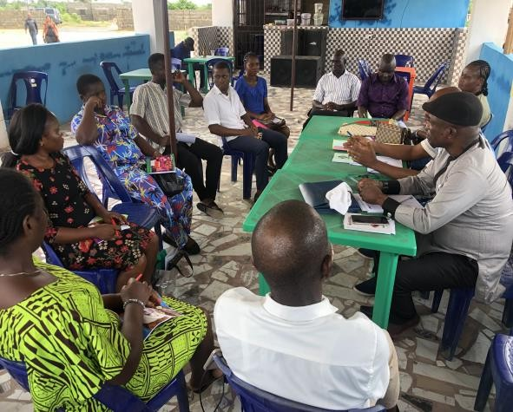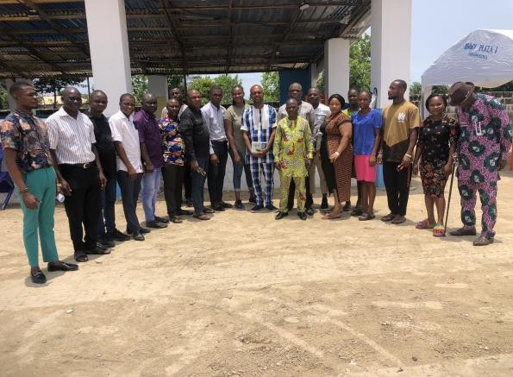
Training of the 16 CSN Members of Eastern Obolo on Climate Change Mitigation, adaptation, business management and communal conflict at Iko on the 01/04/2024
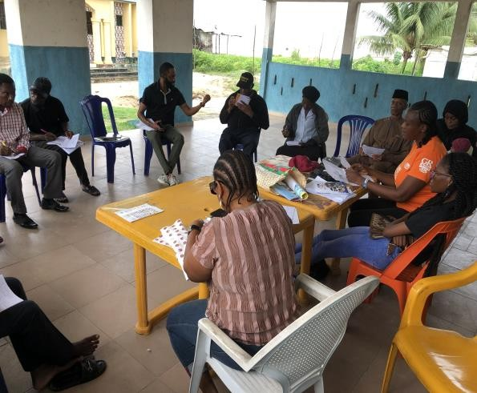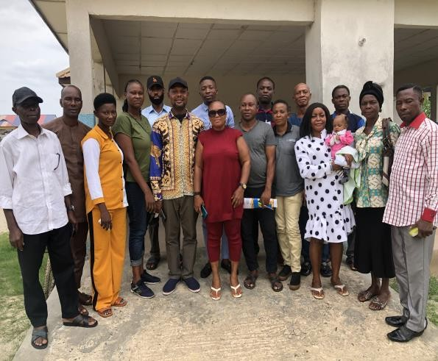
Training of 16 CSN Members of Ibeno on Climate Change Mitigation, adaptation, book keeping and communal conflict at Inua Eyet Ikot on the 05/04/2024
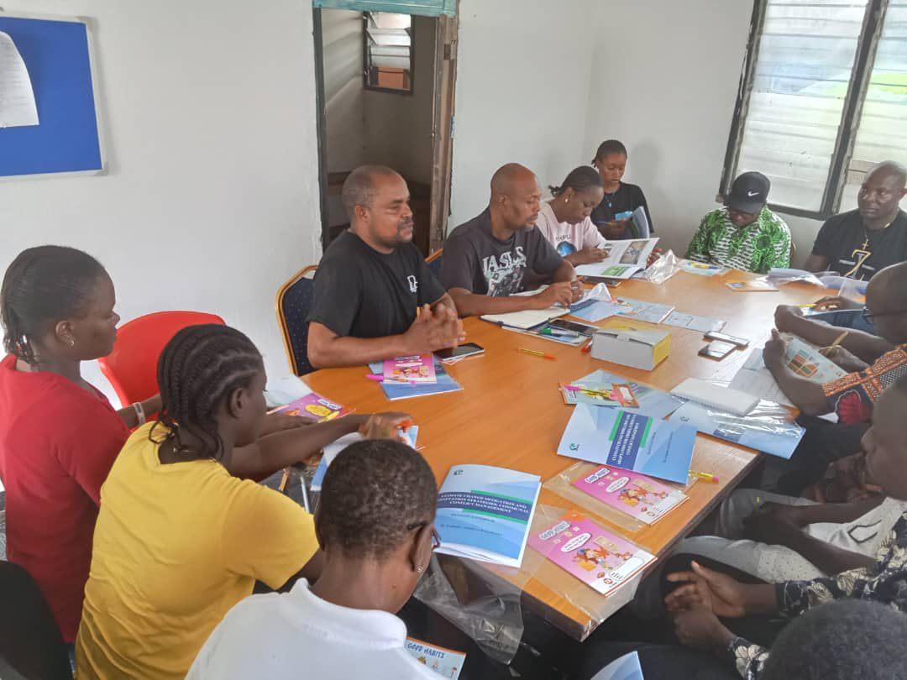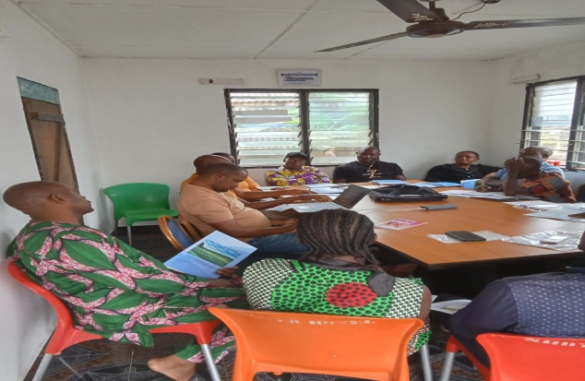
Ongoing training session of the Akassa CSN using the Climate change handbook in Pidgin at Akassa Community on the 1/07/2024

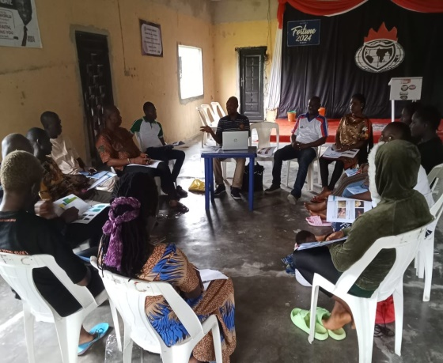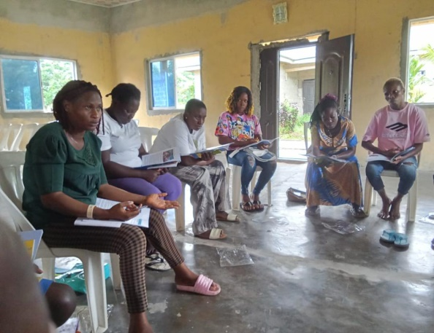
Training of the 16 CSN Members on Climate Change Mitigation, adaptation and communal conflict at Nembe community on the 3/07/2024

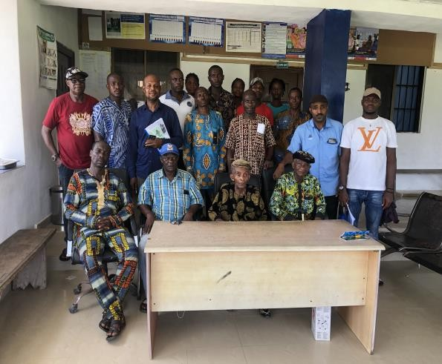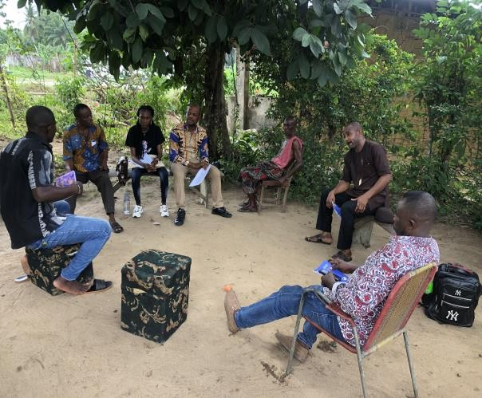
Training of Creek town CSN members on climate change, conflict management, business management, book-keeping on the 25/03/2024
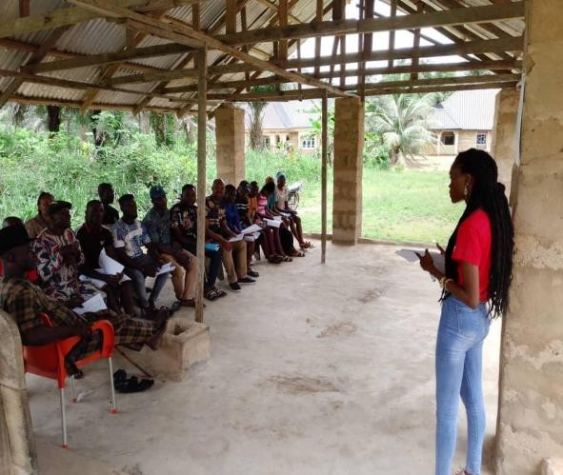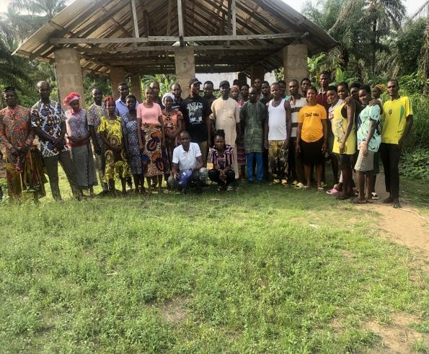
Training of Esuk Mba CSN members on climate change, conflict management, business management, book-keeping at Esuk Mba community on the 27/03/2024
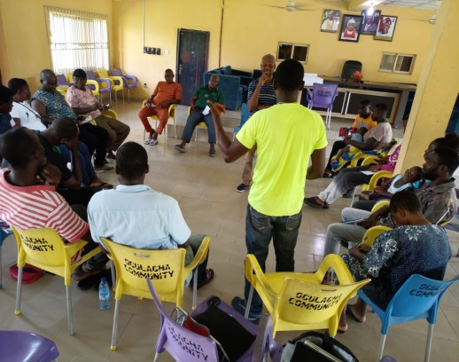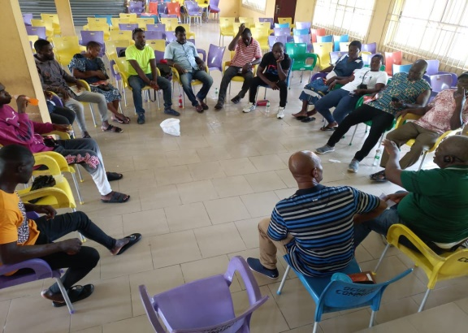
Training of the 16 CSN members using the Climate change handbook in Pidgin English at Ogulagha community on the 12/06/2024
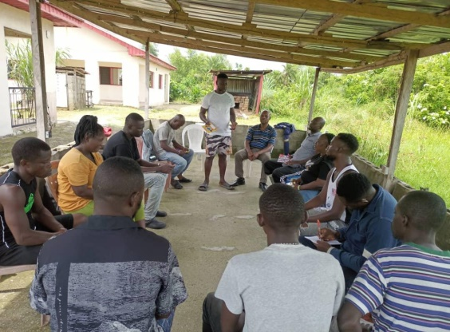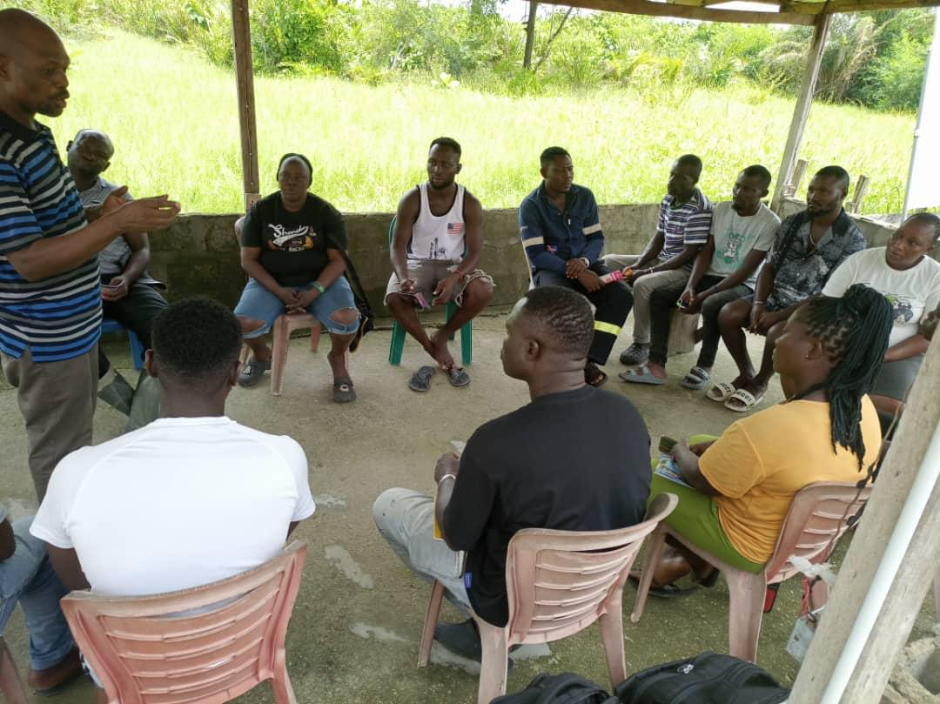
Ugborodo CSN members training using the climate change handbook on the 14/06/2024 in Ugborodo Community
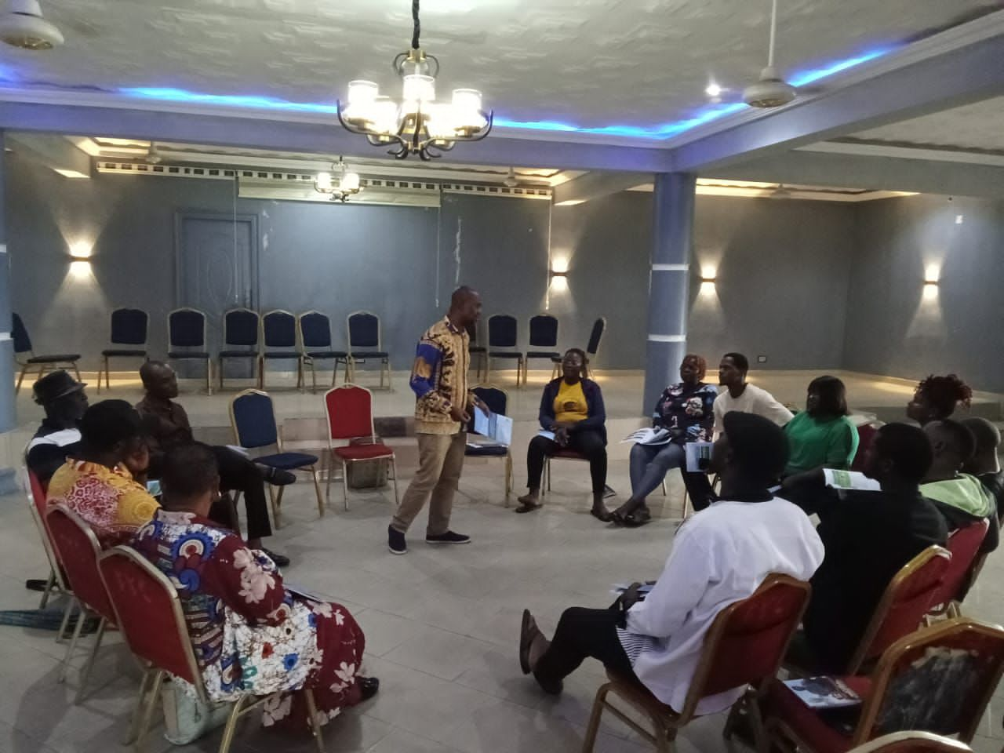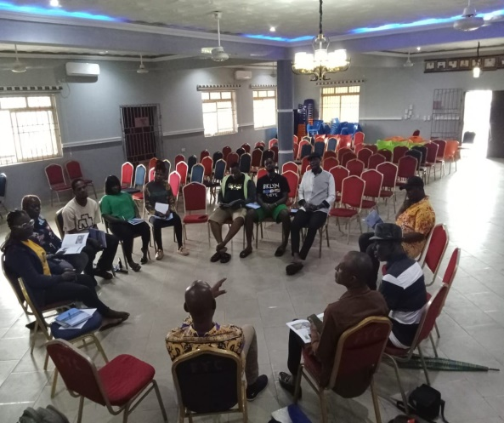
Training of the Kono CSN members on climate change and communal conflict management using the climate change handbook at Kono Community on the 10/07/2024

Next steps:
AAPW prepared a work plan to specify the activities for the training scheduled from August – December, 2024 as shown below:
Work Plan for the Training of Community Stakeholders Networks (CSN) and Community Members in Cross River, Akwa Ibom, Rivers, Bayelsa and Delta states on Climate Change Mitigation, Adaptation strategies and Communal Conflict Management
S/N | Training Activities | State | Local Government Area | Communities | Date
1 | Community Stakeholders Networks (CSNs) Monthly Meetings | All | All | All | Every month from July-December, 2024
2 | Advocacy Visits to the 10 CSN Communities where the community members address agreed upon priorities | All | All | All | July, October and November 2024
3 | Training of 70 participants on understanding climate change; causes, the impacts of climate change, mitigation and adaptation strategies and communal conflict management | Cross River | Odukani | Creek Town | August, 2024
 |  |  | Akpabuyo | Esuk Mba
 |  | Akwa Ibom | Ibeno | Inua Eyet Ikot
 |  |  | Eastern Obolo | Iko & Okoroete
 |  | Rivers | Khana | Kono
 |  |  | Bonny | Finima
 |  | Bayelsa | Brass | Akassa
 |  |  | Nembe | Etieme/Agbakabiriyi/Igbetaewoama
 |  | Delta | Burutu | Ogulagha
 |  |  | Warri South West | Ugborodo
4 | Regional visit to NDDC in Port Harcourt 1 person per state and AAPW | All | All | All | September, 2024
5 | National visit to Niger Delta Affairs in Abuja 1 person per state and AAPW | All | All | All | November, 2024
6 | Report Writing | All | All | All | December, 2024

Report Indicators
Activity | Indicators | Target | Achievement
Development of policy recommendations, advocacy, and capitalization | Number of recommendations for improved integrated governance of security and climate change at national and regional level delivered to national governments | - | -
 | Number of Practical toolkits for policymakers produced | 1 | 1
 | Number of seminars with government officials conducted | 3 | -
 | Number of dissemination and discussion materials for seminars | - | -
Training and Capacity Building for Communities | Training sessions in the Niger Delta | 5 | 1
 | Number of CSN members who participated in the Training |  | 157
 | Communities provided with intensive support(transport refunds and training materials) | 10 | 1
 | Number of advocacies to Law enforcement done (NDDC, NDC, NIMASA, NPF) | 3 | 0
 | Number of Implemented Community monthly meetings | 10 | 8
 | Number of community advocacy events in the region | 3

